**Analysis of Public Housing in Singapore**

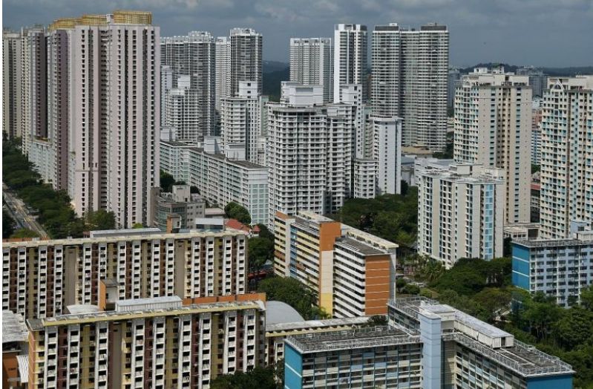

**Purpose**

The purpose of this assignment is to discover insights from the analysis and data visualisation of profile, trends of prices, sale transactions of HDB (Housing Development Board) resale flats over a period of time.   
  
The analysis and data visualisation are to be shown on a dashboard.

**Dataset**

You are given past HDB transactions data file (**C355_Resale_Dataset.xls**).

**Background**

1. Purchase of new HDB Flat

Citizens can buy their flats directly from HDB. Flats bought directly from HDB are cheaper in price because they are brand new flats subsidized by government. Hence, these buyers are first owner of the HDB flat purchased directly from HDB.

A new HDB flat has a life span (lease duration) of *99 years*. The lease period starts from the day (**Lease Start Date**) the buyer collects the key of the new HDB flat.

After a certain period of time, if a first-time owner wants to sell his flat, he can sell to any eligible buyer. His flat for sale is then called a resale flat in the open market (that is, anyone can buy/sell directly with each other).

In this assignment, the focus is on the analysis on sale transactions of resale flats in the open market.

1. Buying/Selling a Resale flat in Open Market

When a buyer, like Peter, wants to buy a 4-room resale flat in Bishan estate, he can buy from a seller who owned such flat.

Note: The seller has already stayed in his flat for some years, so the resale flat’s **Remaining Lease Duration** will be shorter. For example, if the seller bought his new flat directly from HDB on 30 May 1999 (Lease Start Date) and then sold the flat to a buyer on 29 April 2010 (**Resale Date**). So, the seller already stayed in the flat for a length of 11 years (i.e. 2010 minus 1999) *. Then the Remaining Lease Duration of this resale flat is 88 years (i.e. 99 minus 11).

*(*for this assignment, use the Year in the date to calculate*).   
  
The owner of a resale flat (i.e. the seller) usually wants to know the estimated worth of his flat in the open market before selling. So, he will engage a property valuer to calculate the value of the flat. This value is called the **Valuation Price.** The seller can choose to sell below or above this valuation price.

After viewing a few flats, Peter (the buyer) decided to buy a particular resale flat that he liked. He can negotiate a price to buy with the seller. If they agreed with a certain price say, $450K, then the agreed price is called the **Resale Price**. Suppose the valuation price of this resale flat was $400K, then it is said that Peter bought his resale flat at $50K above the valuation price.

**What you need to do**

You are to carry out the following tasks, following the instructions guide in the Worksheet file (**C355_ESE_Worksheet.docx**).

|  |  |  |
| --- | --- | --- |
| **Task#** | **Task** | **Completed by** |
| Task 1 | Understand Business Requirement   * + Examine the dataset carefully to identify the Measures (*what to analyze)* and Dimensions (*how to analyze the identified measures*) in the data set   + Define business questions | End of Lesson 10 |
| Task 2 | Data Preparation   * Clean and prepare data file using Power Query | End of Lesson 11 |
| Task 3 | Analysis and Data Visualisation   * Charts and Dashboard creation * Discovering insights and answer Business questions | End of Lesson 12 |
| Task 4 | Individual oral presentation   * Demo final dashboard in Tableau | End of Lesson 13 |

**Submission**

Please refer to the Worksheet file for the details of assignment’s submission requirement.

--- End of Document ---